Exp. 4. Kronig Penney Model

Name : Kishore R
Reg No : 192512008

Aim:
To simulate Energy functional vs Energy graph using Kronig Penney model
Case Study 1: Simulate the output for Triangular well
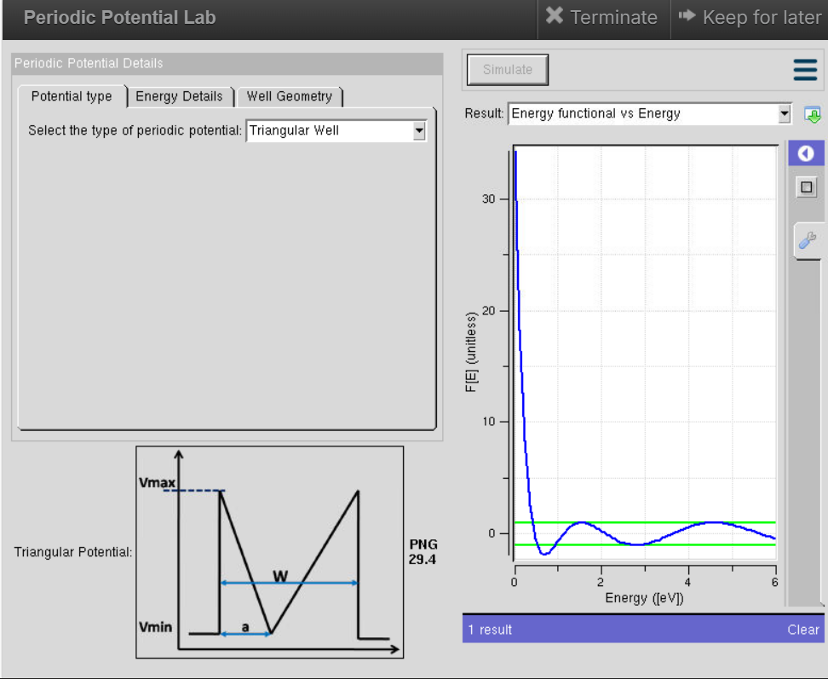

Case Study 2: Simulate the output for Sinusoidal Potential
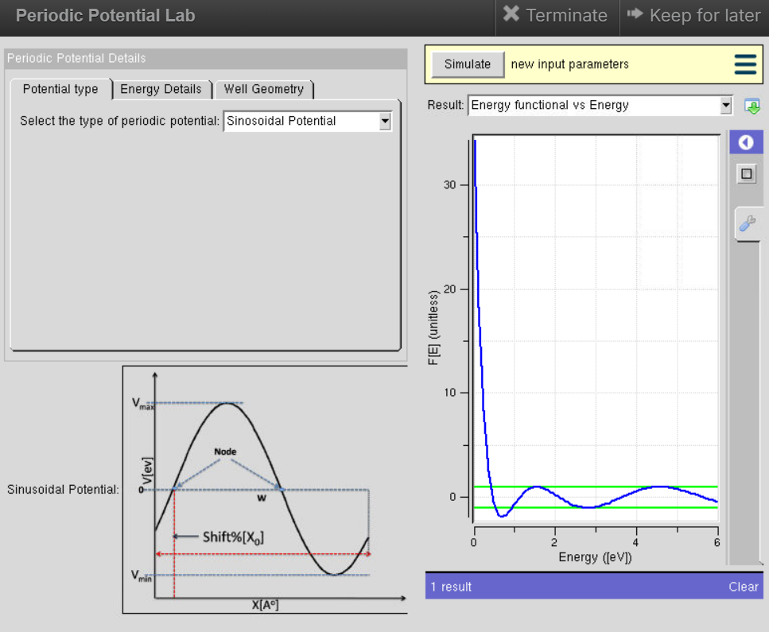

Result:
The energy functional vs Energy graph using the Kronig Penney model is simulated.

